Principles of Inclusive Governance

 | Inclusive Governance means that people from many different backgrounds are included in the decision-making of an organisation.
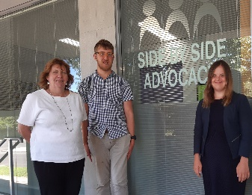 | The Inclusive Governance Project has been looking at the inclusion of people with intellectual disability.
 | Inclusive Governance works best when people with intellectual disability are included in all parts of an organisation.
There are 5 Principles of Inclusive Governance.

These principles guide the way organisations work.
 | 1. We include people with intellectual disability when we are making decisions. We value this inclusion.
 | 2. We make it easy for people with intellectual disability to get involved in our organisation.
 | 3. We make our Board meetings and activities easier for people with intellectual disability to take part.
 | 4. We provide the support that people need.
 | 5. We do whatever is needed to make Inclusive Governance work.

